Interview: Kai Budde, the German Juggernaut

What makes this Magic titan a champ?
Nate Heiss
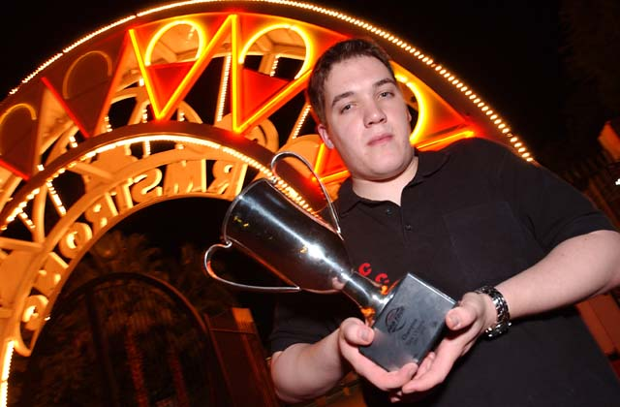
Kai Budde is a name associated with victory. Kai has taken more major wins home than any other player in the game. We have all heard it before, but we are continually amazed as his fantastic performance continues. Only recently was the German Juggernaut stopped at Grand Prix-Biarritz, and by "stopped", I mean that he was defeated in the finals.
Will Kai ever go 0-2 drop? The world may never know.
I managed to get in contact with Kai and schedule an interview. Kai was very receptive, even though this is quite a busy time of year for students worldwide. Enjoy a peek into the mind of Kai!
Sideboard: Tell us about the early part of your Magic career.
Kai: I did some roleplaying with some people I knew from school for about a year or so... they introduced me to Magic, but all of them quit by now, though.
Sideboard: Do you like roleplaying or Magic more?
Kai: Well, that roleplaying was about 4-5 years ago, and I quit after a quite short period. I didn't like it too much.
Sideboard: Do you think that you are the best player in the world?
Kai: I don't really want to judge myself.
Sideboard: That is a fair answer... but you have my vote! Way back when you won your second Grand Prix, I said to myself "He is the next Finkel!"
Kai: (smiles)
Sideboard: Ok, here is another question for you... when did you first realize that you were more broken than Tolarian Academy on a good day? Did it shock you?
Kai: Well lately it has been getting a little ridiculous... I mean there is a luck factor involved, and winning three Pro Tours in a row just doesn't make sense. I don't really know what is happening here either!
Sideboard: I am sure you don't mind it though.
Kai: After Barcelona, I was absolutely sure that I had to stop winning at some point, but then I won London and went to the team Pro Tour with the feeling that I was due to have some bad luck, but that didn't happen... next up was Oslo and I had some really bad draws there while most of my opponents had very good draws, so I thought it would come to an end finally. Enter New Orleans a few weeks later...
Sideboard: Does that make you think there is less luck in the game than you thought before? I mean, that is one heck of a streak! If that is lucky, then you should start flipping coins for cash!
Kai: There is definitely luck involved, no question. I think you can make up for a lot with playtesting and having good decks, but my Top 8 match record is right now 29-2, plus my opponents were all very good players, so that streak is inexplicable to me. If someone told me they had a 29-2 streak in DCI sanctioned local tournaments I'd call the DCI and tell them that he is very likely fixing his rating.
Sideboard: Do you think that someone can become a great player solely via hard work and dedication?
Kai: I'm not sure. I know a few people who play a LOT and have for a long time. But they don't always get results... like some people play a lot of chess but still set up horrible trades.

After Barcelona, I was absolutely sure that I had to stop winning at some point
Sideboard: Like say, me... or Flores maybe? Maybe we are not dedicated enough.
Kai: Well you guys played on the Tour and had some solid finishes (not sure about Flores!).
Sideboard: Do you feel that the people in your playgroup are a large factor in your success?
Kai: In my opinion, I think it is key that you play with people that are on your level, otherwise you can't make progress.
Sideboard: So is it like the same rule of thumb as getting better at chess: play people that are slightly better and slightly worse than yourself?
Kai: If possible play people that are a lot better.
Sideboard: Do you think that if a random scrub got his butt kicked by you all day long, he would make faster progress than normally?
Kai: If I took the time to explain him why he is losing and he listened to my advice, certainly.
Sideboard: What is your favorite part of a Magic tournament?
Kai: The Top 8!
Sideboard: Okay then, what are the two most significant moments in your time playing Magic? I don't mean your two best finishes, I mean things that are important to you personally. Besides, how can you rank your best finishes with so many 1st places?
Kai: Being World Champion was great.
Sideboard: Any perks there?
Kai: Perks?
Sideboard: You know, bonuses.
Kai: Nope.
Sideboard: How about #2?
Kai: 1998 Pro Tour-Chicago was cool, the one Dirk (Baberowski) won. We tested together. Dirk played his first PT and that was the first one I played when I had a rough idea of what I was actually doing. We finished 1st and 19th.
Sideboard: Nice... when was your first Pro Tour?
Kai: My first Pro Tour was Juniors in NY, Rye Brooks. I went 5-2 there, but it was the last Juniors on so it qualified me for the next Pro Tour. I made Top 64 there and then didn't qualify again for about a year. It was pretty funny... in the first draft I beat Kibler and Jamie Parke and then lost to Eric Philips. Kibler actually remembered that.
Sideboard: Did he like dragons back then too?
Kai: That was 5th Edition/Visions, so not many Dragons for Mr. Kibler.
Sideboard: Viashivan maybe? I remember Rye... that was the first Pro Tour I witnessed. What did you do in the meantime while you were not qualified?
Kai: Well I played Pro Tour Qualifiers here and there but I was under 18 so I couldn't really travel, so I played only in the ones nearby.
Sideboard: How old are you now?
Kai: 22
Sideboard: What is the most important advice that you can give our readers?
Kai: My advice would be: Don't take Magic too seriously. It is difficult make enough money off it that it warrants quitting university. Only a few people in the world can do that.
Sideboard: With that last comment in mind, do you feel that you are an ambassador to the game?
Kai: Probably not. I play a lot of small tournaments and stuff, but I am not sure if that makes me an ambassador of the game. I did not really introduce a lot of people to Magic.
Sideboard: Well, you are a positive influence on the people who already play, but I see what you mean.
Kai: I think that I am definitely a positive influence. A lot of people play more because they see how much I am winning.
Sideboard: Okay, last question... but I don't know if you are allowed to answer it. What is your second choice for an Invitational card if your initial idea is rejected... a penguin modifier perhaps?
Kai: I can't talk about that stuff, I think. Randy would probably kill me.
Sideboard: Fair enough, although I miss being able to hassle Randy. Thanks a lot for the interview, Kai!
Kai: Thanks for having me!

